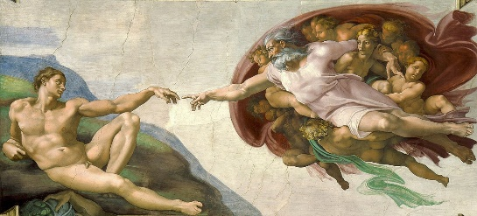

The Creation of Adam, by Michelangelo di Lodovico Buonarroti Simoni, 1508-12

<https://en.wikipedia.org/wiki/The_Creation_of_Adam>

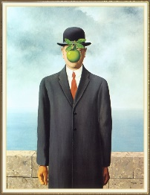

the son of man, by René Magritte, 1964

"Everything we see hides another thing, we always want to see what is hidden by what we see. There is an interest in that which is hidden and which the visible does not show us. This interest can take the form of a quite intense feeling, a sort of conflict, one might say, between the visible that is hidden and the visible that is present." - René Magritte

Appearances

EP5

Apple

Ep5 Ep11

<https://en.wikipedia.org/wiki/The_Son_of_Man>

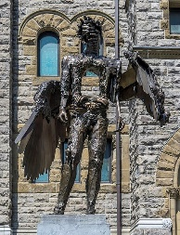

the Eye, by David Altmejd, 2011

Appearances

EP5

<https://artpublicmontreal.ca/en/oeuvre/the-eye/>

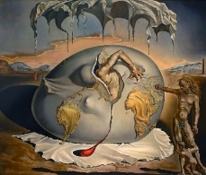

Geopoliticus Child Watching the Birth of The New Man, by Salvador Dali, 1943

Appearances

Ep6

<https://en.wikipedia.org/wiki/Geopoliticus_Child_Watching_the_Birth_of_the_New_Man#:~:text=The%20man%20emerging%20from%20egg,Europe%20to%20support%20his%20emergence>.

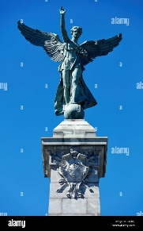

The Goddess of Library, by George William Hill, 1919

<https://en.wikipedia.org/wiki/George-%C3%89tienne_Cartier_Monument>

Appearances

Ep8

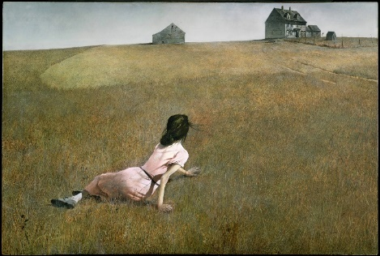

Christina's World, by Andrew Wyeth, 1948

<https://en.wikipedia.org/wiki/Christina%27s_World>

Appearances

Ep11 (ep10 kind of)

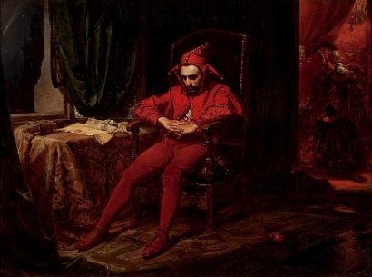

Stanczyk, by Jan Matejko, 1862

<https://en.wikipedia.org/wiki/Sta%C5%84czyk_(painting)>

Appearances

Ep14

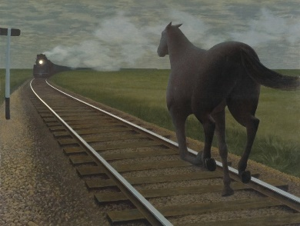

Horse And Train, by David Alexander Colville, 1954

<https://en.wikipedia.org/wiki/Alex_Colville>

Appearances

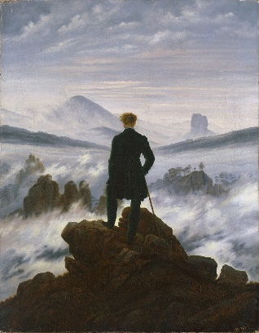

Wanderer Above the Sea of Fog, by Caspar David Friedrich, 1818

<https://en.wikipedia.org/wiki/Wanderer_above_the_Sea_of_Fog>

Appearances

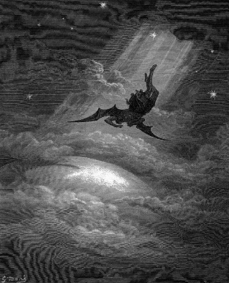

Satan descends upon Earth, by Gustave Doré, 1866

<https://www.artbible.info/art/large/666.html>

Appearances

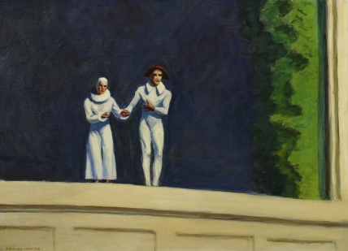

Two Comedians, by Edward Hopper, 1966

<https://en.wikipedia.org/wiki/Two_Comedians>

Appearances

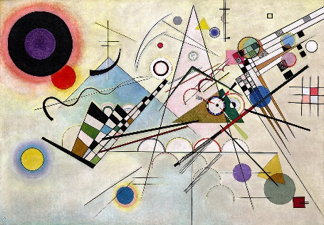

Composition 8, by Vasily Kandinsky, 1923

<https://www.guggenheim.org/artwork/1924>

Appearances

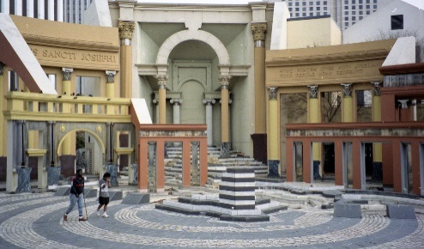

Piazza D'Italia by Charles Moore, 1978

<https://en.wikipedia.org/wiki/Piazza_d%27Italia_%28New_Orleans%29>

Appearances

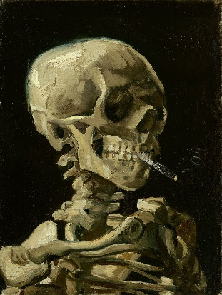

Skeleton with a Burning Cigarette, by Vincent van Gogh, 1885-1886

<https://en.wikipedia.org/wiki/Skull_of_a_Skeleton_with_Burning_Cigarette>

Appearances

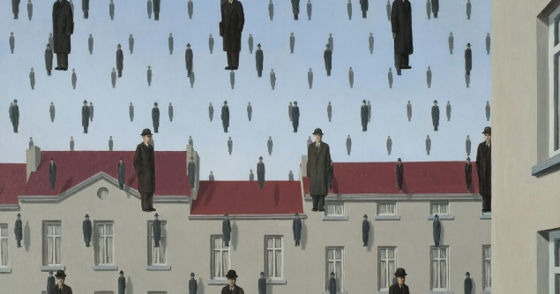

Golconda, by René Magritte, 1953

<https://en.wikipedia.org/wiki/Golconda_%28Magritte%29>

Appearances

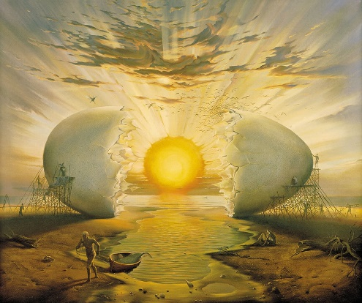

Sunrise by the Ocean, by Vladimir Kush, 1996

<https://kushfineart.com/artworks/categories/8/9559-sunrise-by-the-ocean>

Appearances

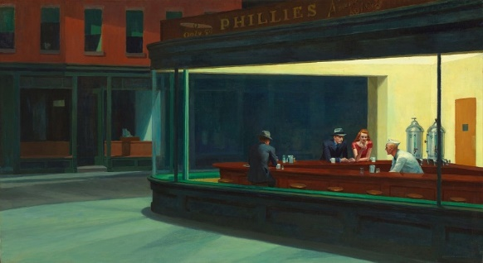

Nighthawks, by Edward Hopper, 1942

<https://en.wikipedia.org/wiki/Nighthawks_(Hopper)>

Appearances